After completing Spider Game #2702606759 on March 17, 2022 at 11:44am, got the “Congratulations!” window, but my score was a loser, #7, from the previous day.

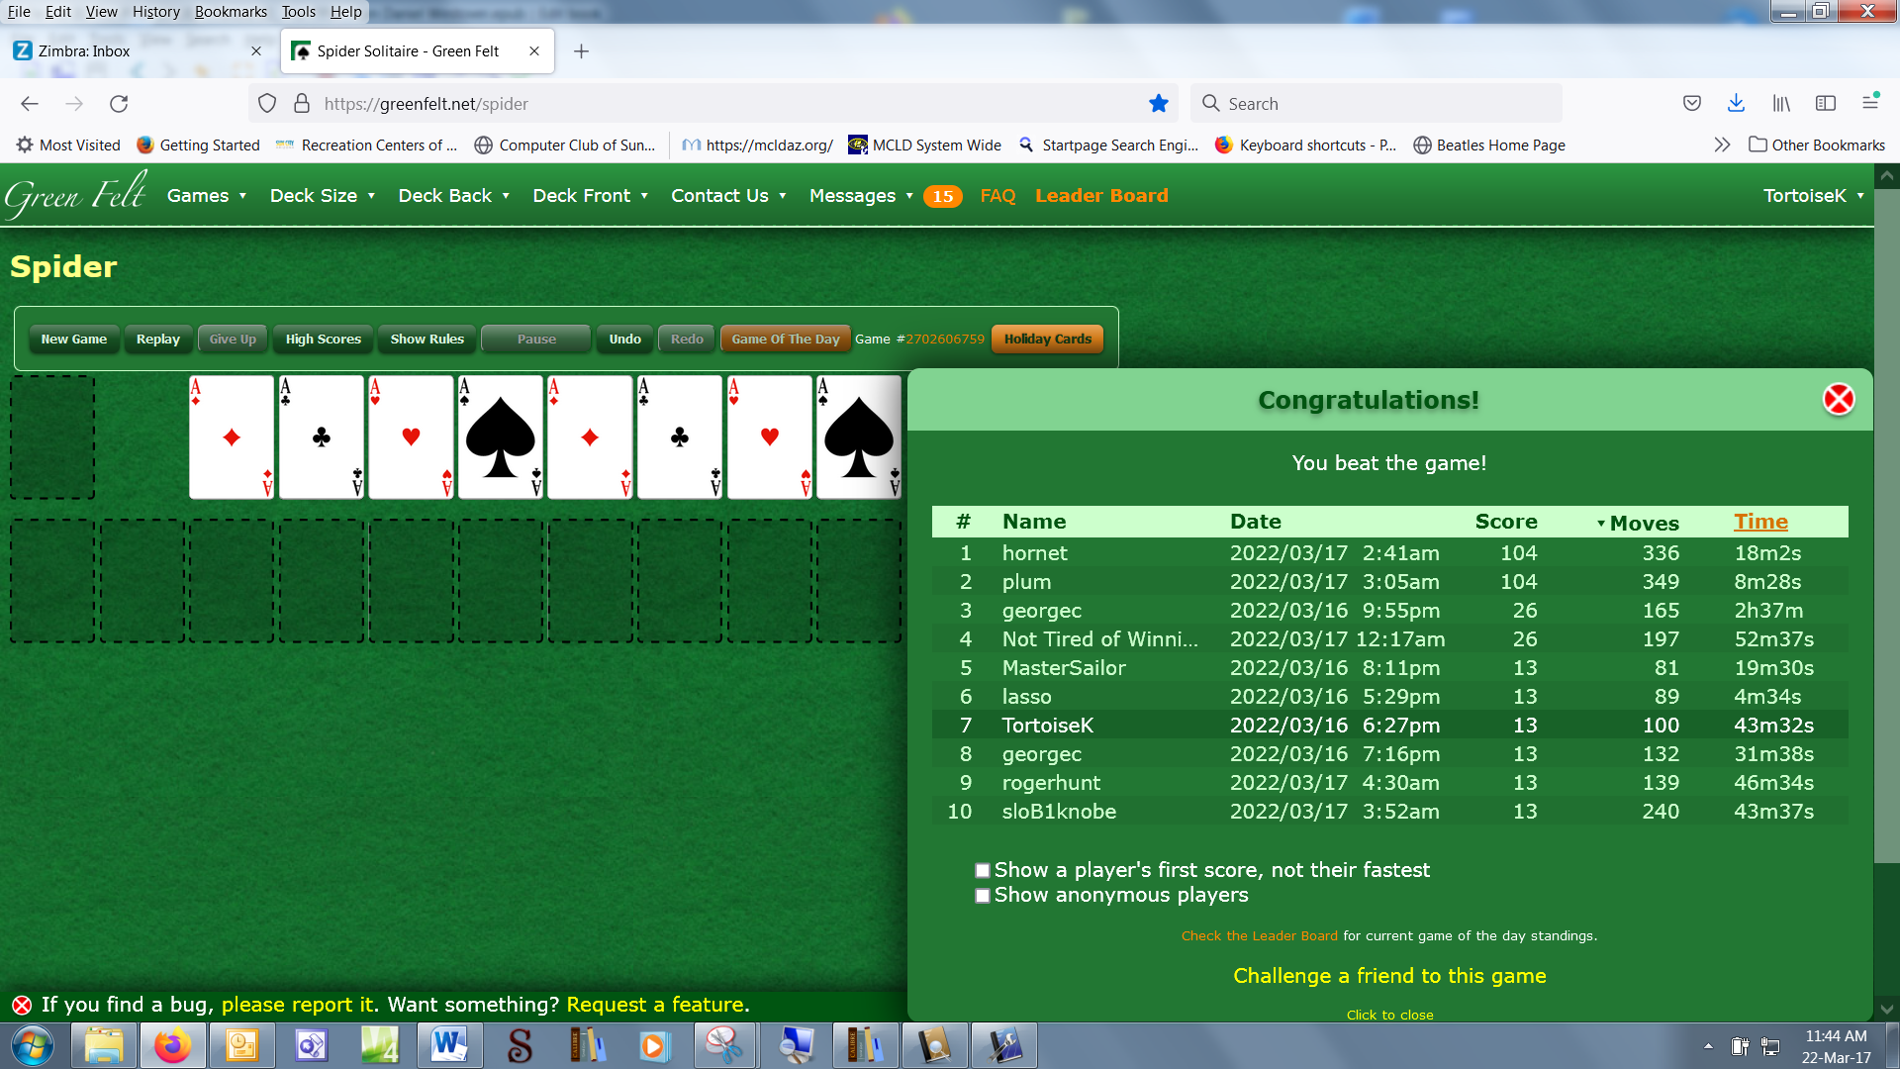

Here’s the Leader Board 11 minutes later:
